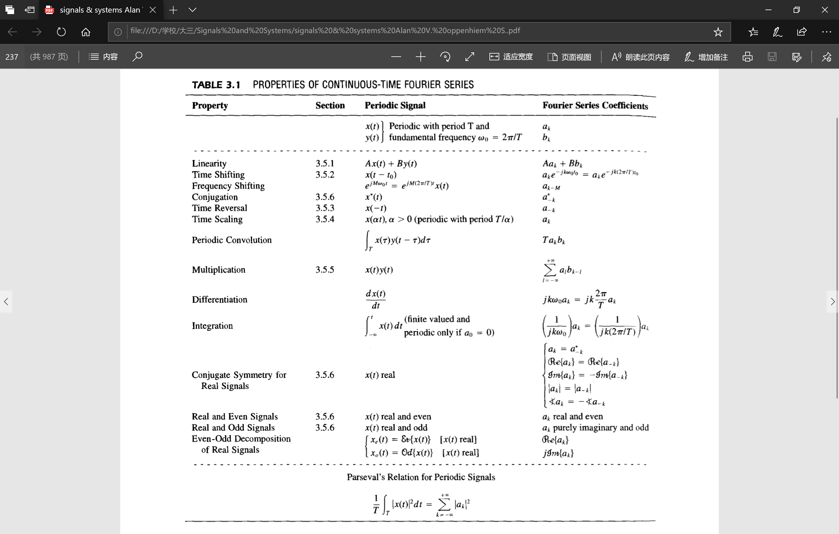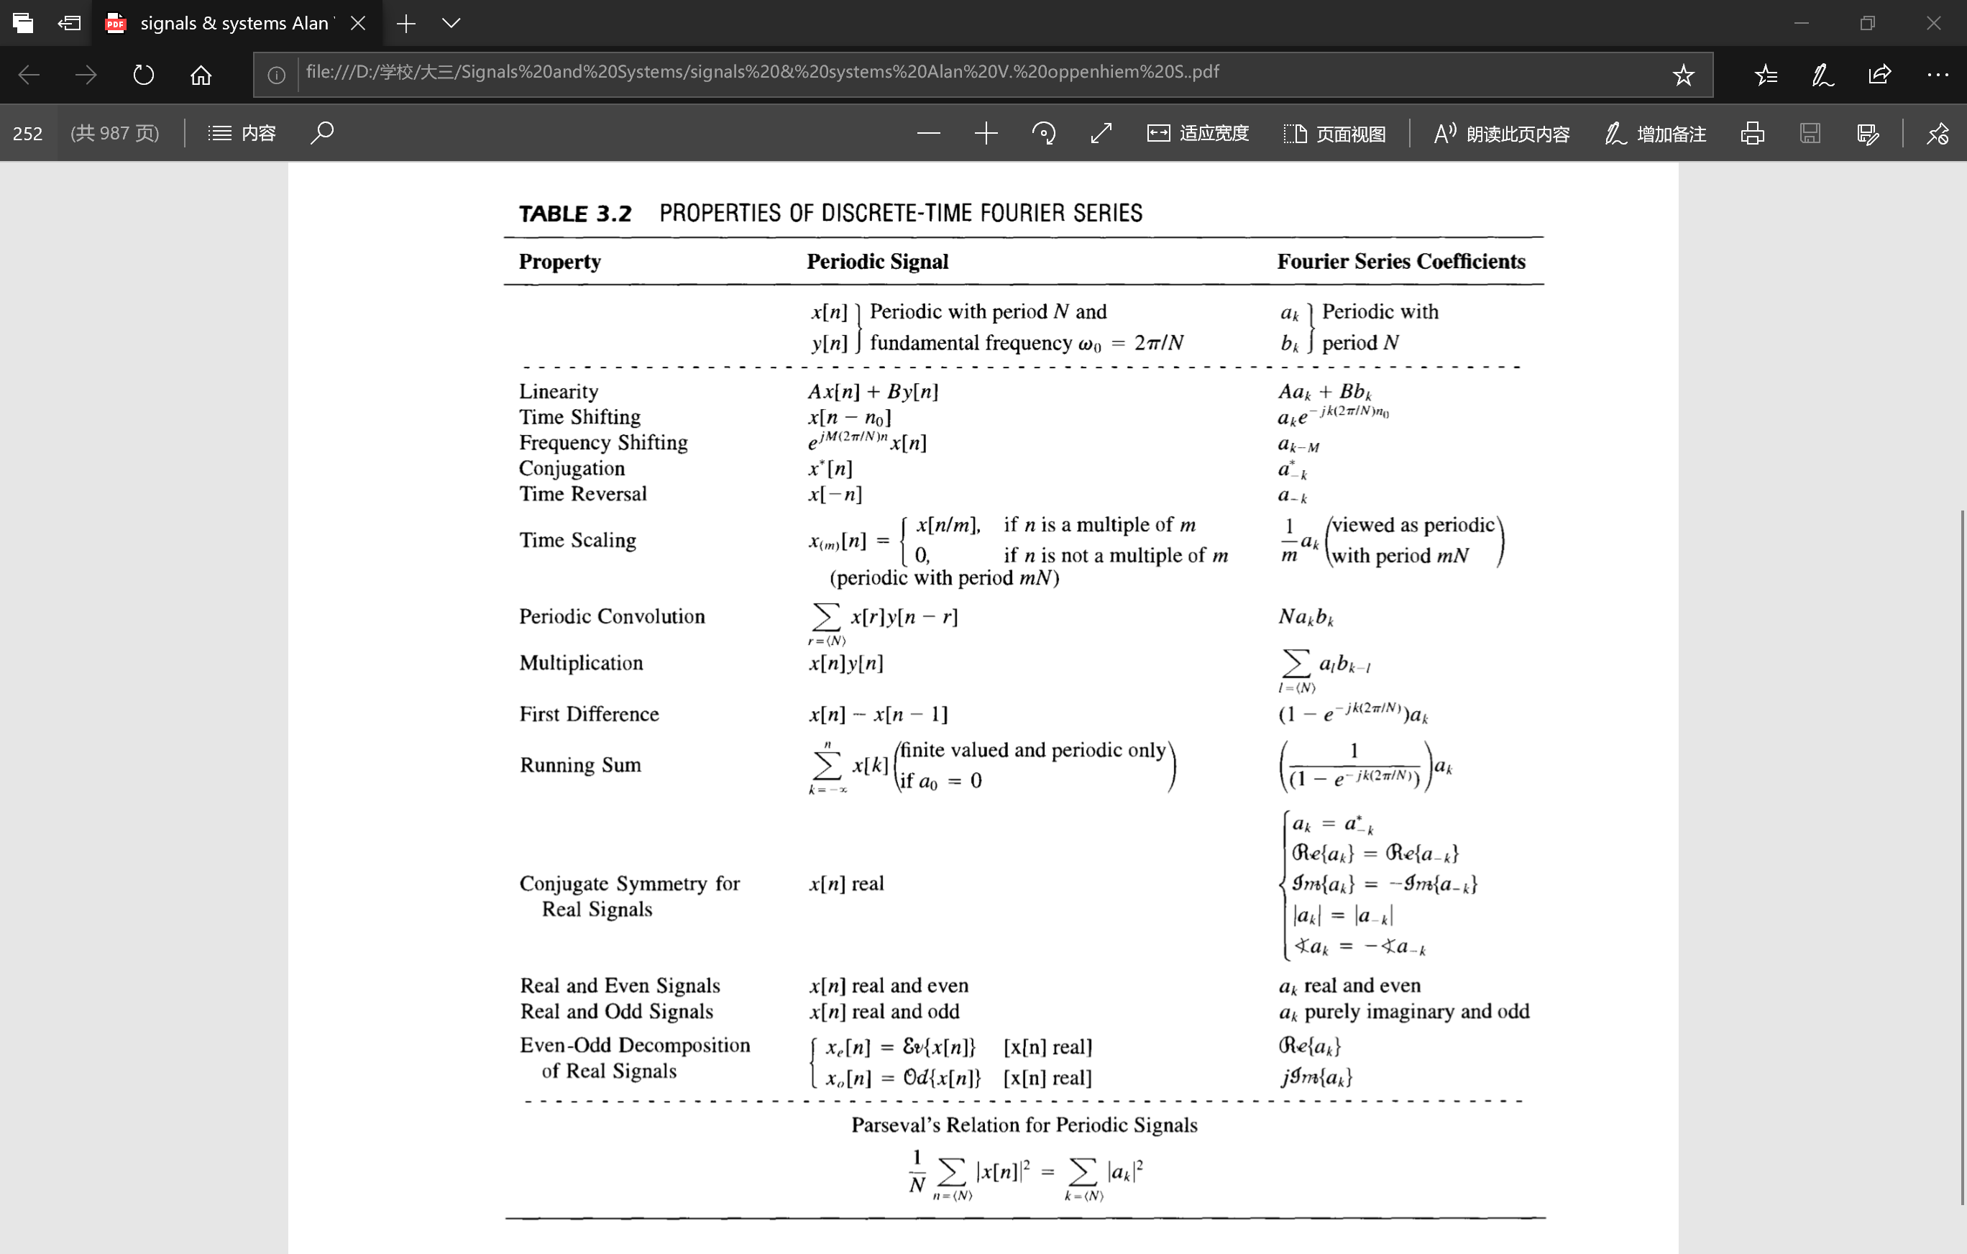

**Nth order linear constant-coefficient differential equation**

Expression:

Solution: , where

Causal and LTI ⬄ Initial rest (i.e. if for then for )

**Nth order linear constant-coefficient difference equation**

Expression:

Solution: , where

Causal and LTI ⬄ Initial rest (i.e. if for then for )

**Real, even, odd properties of a signal**

If is real, then from the synthesis equation:

If is real and even, then ;

Hence is real and even.

Similarly, if is real and odd, then and , is purely imaginary and odd.

**自变量变换**

Systematic approach:

**和差化积公式与积化和差公式**